Learning objectives:
Colours
- Be able to identify different colours and name them in multiple languages
- Understand how colours can be mixed together to make different colours

Materials needed:
- Different colour tyres or playground elements
- Red, Yellow and Blue paint - Skipping rope
- Paper - Paint brushes
- Water to wash paint brushes

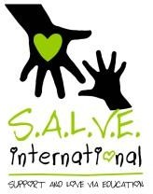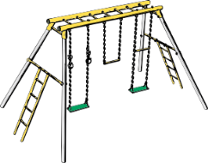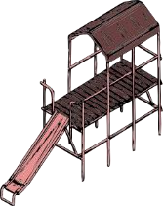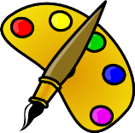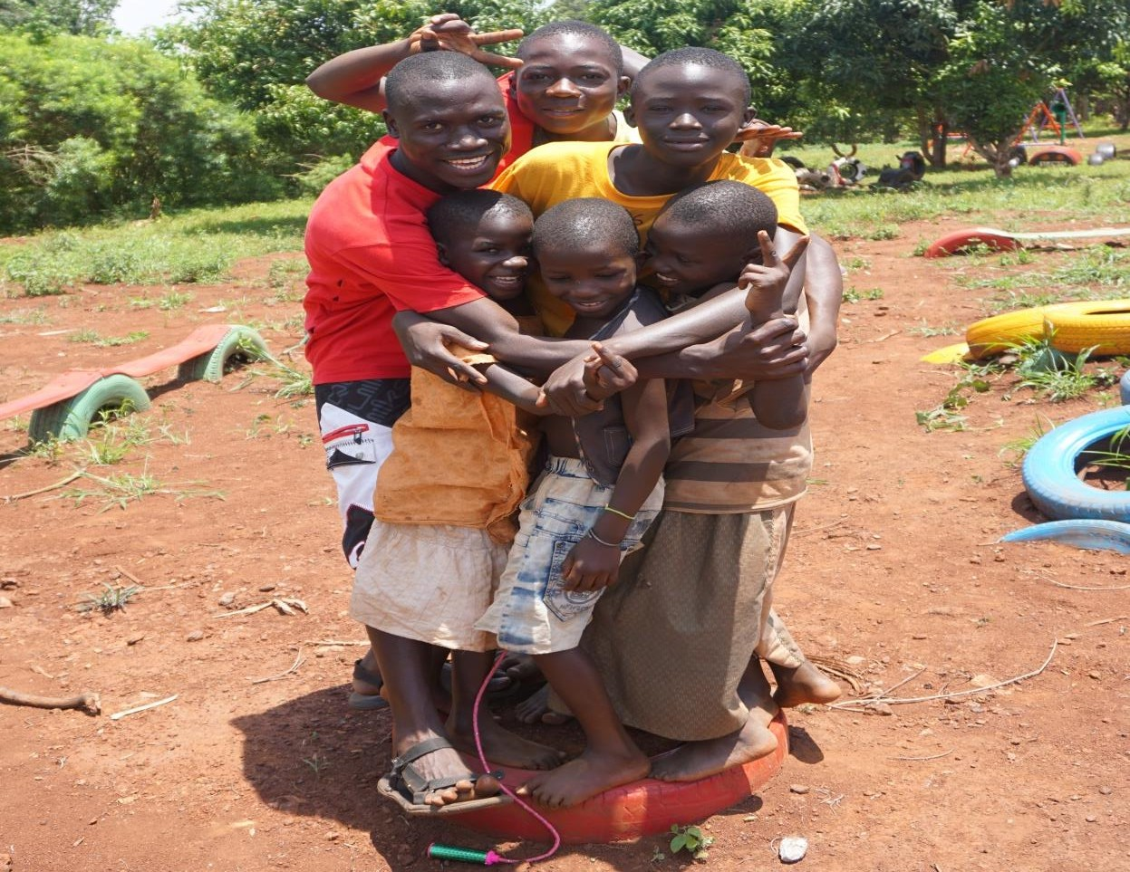Time
5
mins

5
mins 15
mins

15
mins

10
mins

Running the Session:
- Ask the children to stand in a circle then look at each other’s clothes and name as many colours as they can find. Ask them to help each other if there are some colours they are struggling to name.
- Go around the circle and tell each other what your favourite colour is and why. Teacher can give an example of their favourite colour first.
- Ask the children to name all the colours they can see in the playground. Then explain we are going to play a game. Separate the children into groups and give each group a skipping rope to hold. Explain that all members of the group must hold onto the rope at all times. If they drop the rope or leave a child behind they will lose one point. You will shout out a colour and they as a team have to move to touch an item of that colour. Everyone in the team must be touching the item. The first team to all be touching the item will get one point. Demonstrate an example so that everyone clearly understands.
Play the game until the winning team has 10 points.
- Come back to your circle and have everybody sit down. Explain that we are going to mix colours to see how we can make different colours starting with red, yellow and blue.
Hand out pieces of paper, paint and paint brushes.
Ask the children to use any colour of their choice and divide their paper into 3 columns and 6 rows. In the left hand column we are going to put a block of the colour. In the middle column we will write the name of the colour in our language. Then in the third column we will write the name of the colour in a different language (chosen by the teacher).
Ask the children which colours they are making when they mix different colour combinations. You should end up with red, yellow, blue, green, purple and orange written in 2 different languages.
- Play the game again where the children touch colours as a team, but this time name colours mixed between the two different languages.

Time taken:

50 minutes

This resource was produced thanks to the kind support of The British and Foreign School Society. These lessons have been designed and used by staff from S.A.L.V.E. International to explore creative play learning using a playground with street- connected children in Uganda. www.salveinternational.org
