Learning objectives:
The Gravity Slide
- Understand what gravity means
- Be able to give examples of gravity in day to day life
- Understand that the size of the object doesn’t impact
how much gravitational pull there is, it’s the Earth’s size that matters.

Materials needed:
- Slide - Stop watch
- Stones or a football
- 7 Pieces of paper each with one letter of the word GRAVITY
- Blue tack or selotape to stick the letters around your playground

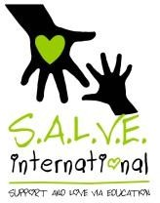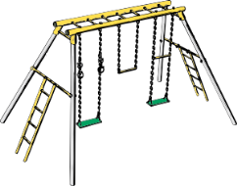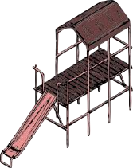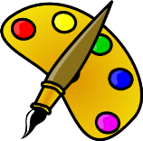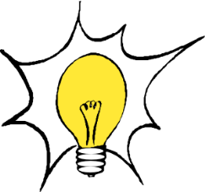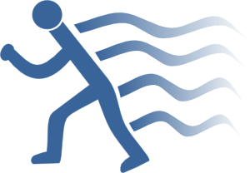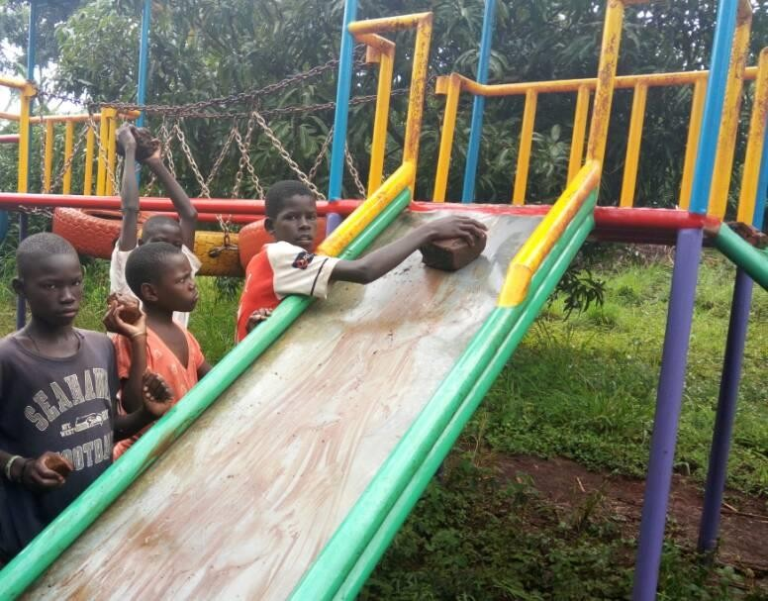Time
10
mins 5
mins

5
mins

5
mins

5
mins

10
mins

5
mins 5
mins

Running the Session:
- Before the class starts go and hide the 7 letters spelling out the word GRAVITY around the playground.
- Explain to your students that you have hidden some
Letters around the playground and you want them to find them all and then spell out the topic of today’s class.
- When the students have found the letters and spelt out the word gravity on the floor, then ask them what they think gravity means?
- Ask clarifying questions to help the group reach an understanding that gravity is the pull (or attraction) that keeps objects from floating away from the Earth.
- Gravity is very important to our everyday lives. Ask students to tell you how gravity helps them in their daily lives. Some examples might include playing football (the ball doesn’t float away) and eating food (the food stays on the plate). Try to get one from each child.
- Bring your students to the slide. Ask for 2 children to demonstrate what happens when they sit at the top of the slide and then push off. Do they float away into the air? Why not?
- Now ask your students if they think the size of the object being pulled to the Earth will affect the speed of the gravitational pull, i.e. will bigger and heavier things fall faster?
- Organise a race to explore this either by using two slides together or by timing a child versus a smaller object going down the slide. Help the children to reduce any factors that might affect the experiment so that they are able to see that size doesn’t impact on the speed of falling. Explain it’s the size of the Earth that matters and its pull is the same no matter how big the item is.
- Ask the children (in small groups) to find as many other parts of the playground which demonstrate gravity as possible i.e. seesaw and swings.
- Come back together as a group to see how many items in the playground demonstrate gravity for us.
Finally ask the children to reflect on what they learnt in this session.

Time taken: 10 minutes (Prep)

40 minutes (Class)

This resource was produced thanks to the kind support of The British and Foreign School Society. These lessons have been designed and used by staff from S.A.L.V.E. International to explore creative play learning using a playground with street- connected children in Uganda. www.salveinternational.org
