Citizenship Teaching Pack
This lesson pack offers 1 lesson and a set of extension activities designed to help explore the issue of children living on the streets worldwide. Lesson 1 is a 60-minute lesson introducing pupils to children’s rights and children living on the streets.

This Lesson Pack

This lesson aims to help equip young people with the knowledge, skills and understanding to play an effective role in public life. It helps pupils to become informed, critical, active citizens who have the confidence to work collaboratively and the conviction to take action and try to make a difference in their communities and the wider world.
A BIG thank you from S.A.L.V.E.
This resource has been designed by S.A.L.V.E. International, a charity that works with children living on the streets in Uganda. We are so excited you’re interested in using our resources to raise awareness about children’s rights and children living on the streets and thank you in advance for taking the time to teach your pupils about these issues! We value your feedback so don’t hesitate to get in touch at info@salveinternational.org.
Citizenship
Global issues: These lessons introduce pupils to global and topical issues of poverty and homelessness. They encourage children to take an interest in different cultures and develop their critical thinking and debate skills.

Lesson 1: Children’s Rights
Lesson 1 and Curriculum
Using children’s rights as a way of exploring the curriculum key concept ‘Rights and responsibilities’, this section of the lesson pack explores the idea of human rights and how these affect both individuals and communities. It helps to develop pupils understanding that individuals, organisations and governments have responsibilities to ensure that rights are balanced, supported and protected.

Learning Objectives
- To explore the idea of ‘Rights’ within Citizenship
- To introduce the UN Convention on the Rights of the Child
- To explore some of the key articles of the Convention

Activity 1: (20mins)
Resources: Interactive whiteboard or projector
Use the Citizenship PowerPoint to introduce ‘rights’ and the UN Convention on the Rights of the Child. (You can print the slides and notes together by going to ‘Print Preview’ and selecting ‘Notes’)

Activity 2: (15mins)
Resources: 1 piece of paper per group.
Split the class into small groups. Ask each group to make a list of the ten rights they think all children of the world should have. Ask each group to tell the class what they have included. Does everyone agree with the rights that have been chosen? Why? Why not?
Activity 3: (10mins)
Resources: 1 Summary of the Convention on the Rights of the Child (included below) per pupil.
Hand out the Summary of the Convention. Get pupils to read through it independently. Ask each group to compare their list with the Convention on the Rights of the Child among themselves and then feedback as a class.
Activity 4: (10mins)
Resources: 1 large piece of blank paper per group. 1 sheet of ‘rights cards’, cut up (included below).
Explain that the groups will compete against each other to identify sketched rights.
To play: A player from each group comes to the front of the class so you can show them all one of the ‘rights cards’ simultaneously. The players rush back to their group and begin to draw while their group try to guess the article being drawn. The artist cannot talk, they can only nod or shake their head in response to their team members’ guesses. They must not use numbers, letters or symbols. The first group to guess correctly raises their hand and then sends their next artist up to the teacher for their second rights card (players take it in turn to be the artist). Meanwhile, the other groups continue drawing until they have also guessed the correct article, whereupon they too send up their next artist. The winning group is the first to have identified all of the rights cards.
Activity 5: (5mins) Recap and debrief against lesson objectives.
Summary of the UN Convention on the Rights of the Child

Article 1: Everyone under 18 has all the rights in this Convention.
Article 2: The Convention applies to everyone under 18, whatever their race, gender, religion, background or abilities.
Article 3: All organisations concerned with children should work towards what is best for each child.
Article 4: Governments should make these rights are protected.
Article 5: Families have responsibility to help children exercise their rights and ensure their rights are protected.
Article 6: All children have the right to life.
Article 7: All children have the right to a legally registered name, a nationality and the right to know and, as far as possible, to be cared for by their parents.
Article 8: Governments should respect children's right to a name, a nationality and family ties.
Article 9: Children should not be separated from their parents unless it’s for their own good.
Article 10: Families who live in different countries should be allowed to move between those countries so that parents and children can get back together as a family.
Article 11: Governments should take steps to stop children being taken out of their own county illegally.
Article 12: Children have the right to say what they think should happen, when adults are making decisions that affect them, and to have their opinions taken into account.
Article 13: Children have the right to get and share information, as long as the information is not damaging.
Article 14: Children have the right to think and believe what they want and to practise their religion, as long as they are not stopping other people from enjoying their rights.
Article 15: Children have the right to meet together and to join groups and organisations.
Article 16: Children have a right to privacy.
Article 17: Children have the right to reliable information from the mass media.
Article 18: Both parents share responsibility for bringing up their children, and should always consider what is best for each child.
Article 19: Children should be properly cared for and protected from violence, abuse and neglect by their parents or anyone else who looks after them.
Article 20: Children who cannot be looked after by their own family must be looked after properly, by people who respect their religion, culture and language.
Article 21: When children are adopted the first concern must be what is best for them.
Article 22: Children who come into a country as refugees should have the same rights as children born there.
Article 23: Children with any kind of disability should have special support to lead full and independent lives.
Article 24: Children have the right to good quality health care and to clean water, nutritious food and a clean environment so that they will stay healthy.
Article 25: Children looked after by their local authority should have their situation reviewed regularly.
Article 26: The Government should provide extra money for the children of families in need.
Article 27: Children have a right to a standard of living that is good enough to meet their physical & mental needs.
Article 28: Children have a right to an education.
Article 29: Education should develop each child's personality and talents to the full.
Article 30: Children have a right to learn and use the language and customs of their families.
Article 31: All children have a right to relax and play, and to join in a wide range of activities.
Article 32: Government should protect children from work that’s dangerous or harms their health or education.
Article 33: Children should be protected from dangerous drugs.
Article 34: Children should be protected from sexual abuse.
Article 35: The Government should make sure that children are not abducted or sold.
Article 36: Children should be protected from any activities that could harm their development.
Article 37: Children who break the law should not be treated cruelly.
Article 38: Governments should not allow children under 15 to join the army.
Article 39: Children who’ve been neglected or abused should receive special help.
Article 40: Children who are accused of breaking the law should receive legal help. Prison sentences for children should only be used for the most serious offences.
Article 41: If national laws protect children better than the articles of the Convention, then those laws should stay.
Article 42: The Government should make the Convention known to parents and children.
Write the categories, ‘Agree’ and ‘Disagree’ on the white board. Read out each
statement and ask the students where they think each statement should go. Have a
student come up and write the statement under their chosen heading. Read out the
information relating to each one and then ask the students if they think the statement
should stay in the same place or be moved

Rights Cards for Activity 4
The right to meet together with other children; to join groups, clubs and associations.  Article 15 | The right to relax and play.  Article 31
The right to express an opinion.  Article 12 | The right to a name which is legally registered.  Article 7
The right to good quality healthcare.  Article 24 | The right to nutritious food and clean water.  Article 24
The right to an education.  Article 28 | The right to a decent  standard of living.  Article 27
The right to be protected from dangerous work.  Article 32 | The right to be protected and cared for properly.  Article 19
The right to information.  Article 13 | The right to think freely and have a religion.  Article 14

(Cut up to prepare)

Extension Activities: What can you do?
These activities are designed to teach pupils about decision-making and different forms of action. Explored using the example of children living on the street, this teaches pupils transferable skills about how to make informed and responsible actions that will help them play an active role in the life of their schools, neighborhoods, communities and wider society. Learning to argue a case on behalf of others as well as themselves and speak out on issues of concern develops pupils’ advocacy skills and encourages them to think creatively about solving problems.

Learning Objectives:
- To encourage pupils to think creatively about what actions they can take as global citizens.
- To give students the confidence to take actions that positively change their world.
- To give pupils experience in arguing a case about a topical issue.

Activity 1: (10mins)
Use the quiz (below and in the PowerPoint) to recap some key points of the last lesson. Quiz can be completed individually or in groups. (Answers: 1A, 2C, 3A, 4B, 5B, 6C, 7A, 8C, 9B, 10C, 11B, 12B, 13A)

Activity 2: (10mins)
Remind pupils that children living on the streets are often abused, ignored, criminalised and disregarded. Unable to go to school and forced to face the harsh realities of life on the streets, they are being denied a childhood. But they’re also being denied a future as children who grow up on the streets become trapped in a cycle of poverty and social exclusion. Brainstorm ways pupils can help children living on the streets at home and in other countries. (Possible answers to include: fundraising, volunteering, challenging stereotypes (via blogs/websites/social media/posters), lobbying Government/their MP, writing letters, rallies, awareness raising ‘stunts’ e.g. mass street sleeps, voting for political parties who talk about global education/street children, buying Fairly traded products).

Activity 4: (20mins)
Get pupils to write a letter to their MP explaining the problem of children living on the street and urging them to take action. Or get pupils to design a poster to raise awareness of children living on the streets. What would their key messages be?

Take Further Action!

If after learning about children on the streets you and your pupils are interested in taking further action, please see the ‘Schools Awareness Raising Pack’ on our website for suggested actions and activities, campaigning advice and guidance on how to contact your MP and the local media. There’s also a Fundraising Pack and a whole host of ways you can get involved with the work of S.A.L.V.E. International to reduce the number of children living on the streets in Uganda.
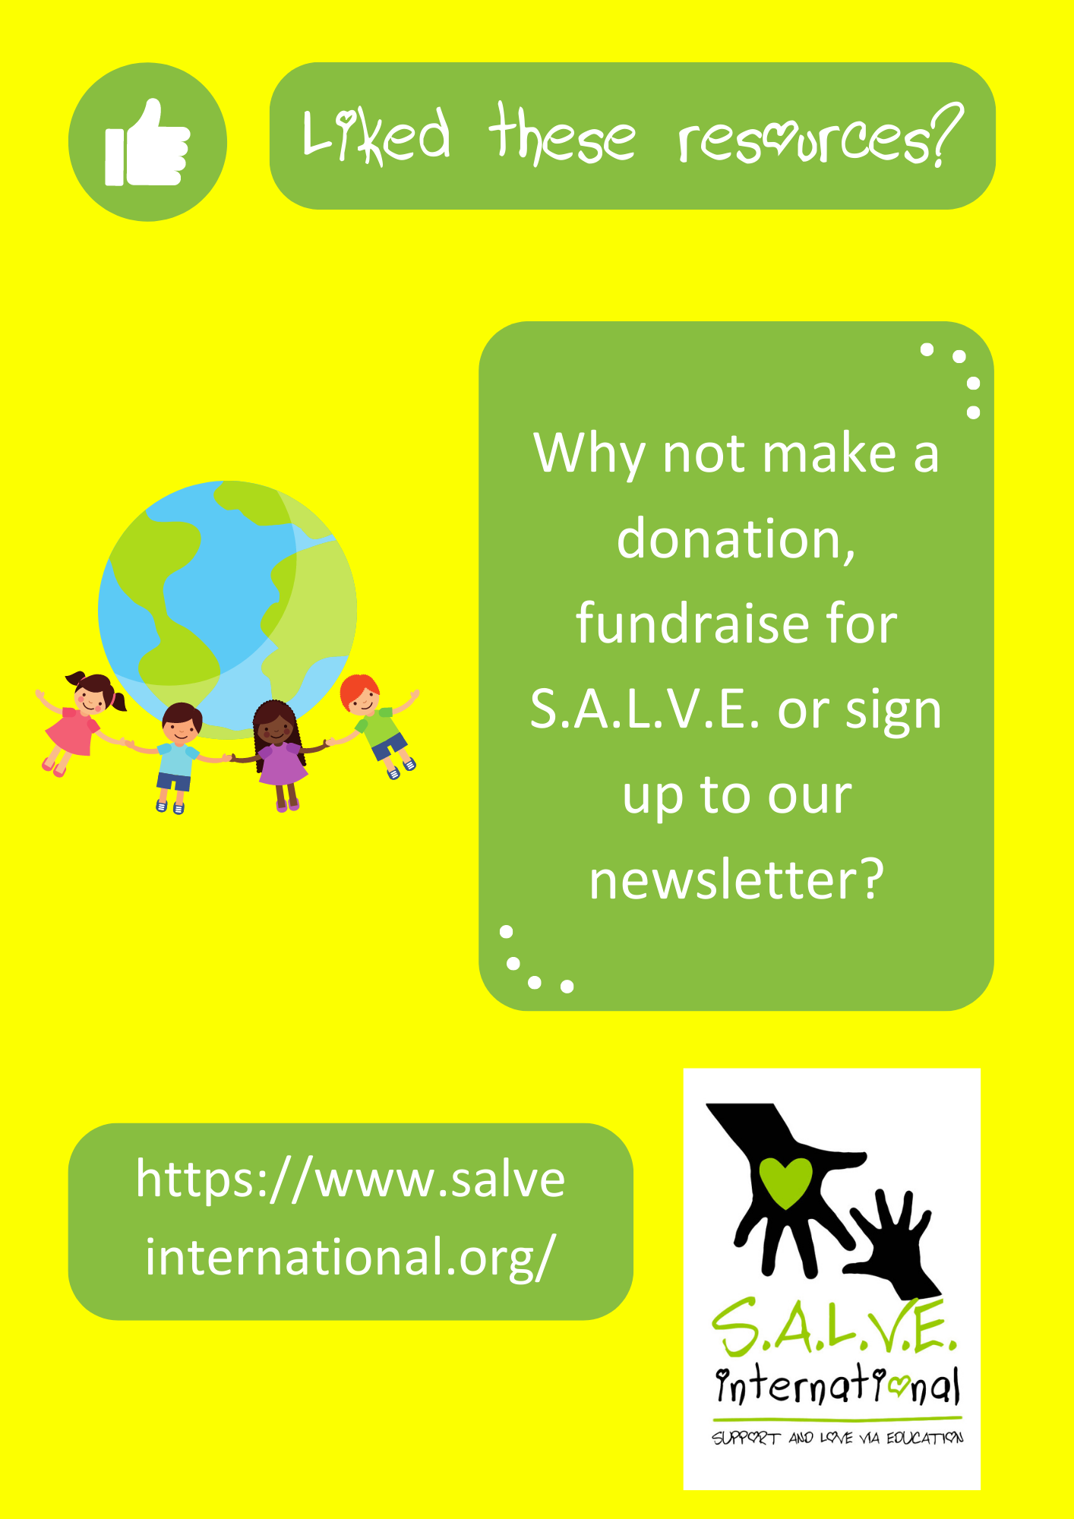

Thank you again for using these resources – we hope they were useful. We’d really value your feedback so don’t hesitate to get in touch at info@salveinternational.org.

Photo Credits for teaching pack:
Picture 1: Mike Asiya, Salve International

Photo credits for PowerPoint presentation:
Slide 1: (Clockwise from top left): 1. Jonathan McIntosh 2. Tanvirul Islam 3. Zirland 4. Peter Rimar 5. Biswarup Ganguly 6. Esther Dobson 7. Predrag Bubalo 8. Esther Dobson 9. Biswarup Ganguly 10. Sumanth Garakarajula
Slide 3: (Top to bottom) 1. Public Domain Photo, US Federal Government 2. Wilfred Huss 3. http://www.liberty-human-rights.org.uk/index.php
Slide 4: (Top to bottom) 1. Inphonic 2. Wilfred Huss 3. UNICEF
Slide 7: (Top to bottom) 1. Chris Erbach 2. Yann Talk 3. Tomchiukc
Slide 9: (Clockwise from top left): 1. Jonathan McIntosh 2. Tanvirul Islam 3. Zirland 4. Peter Rimar 5. Biswarup Ganguly 6. Esther Dobson 7. Predrag Bubalo 8. Esther Dobson 9. Biswarup Ganguly 10. Sumanth Garakarajula
Slide 10: Jonathan McIntosh
Slide 11: Sumanth Garakarajula
Slide 12: Tanvirul Islam
Slide 13 (Left to right) 1. Jonathan McIntosh 2. Predrag Bubalo 3. Biswarup Ganguly
Slide 14: S.A.L.V.E International
Slide 15: S.A.L.V.E International
Slide 17: S.A.L.V.E International
Slide 18: (Top to bottom) 1. Sumanth Garakarajula 2. Peter Rimar 3. Jonathan McIntosh
Slide 19: S.A.L.V.E International
Slide 20: (Clockwise from top left): 1. Jonathan McIntosh 2. Tanvirul Islam 3. Zirland 4. Peter Rimar 5. Biswarup Ganguly 6. Esther Dobson 7. Predrag Bubalo 8. Esther Dobson 9. Biswarup Ganguly 10. Sumanth Garakarajula
Slide 22: (Clockwise from top left): 1. Jonathan McIntosh 2. Tanvirul Islam 3. Zirland 4. Peter Rimar 5. Biswarup Ganguly 6. Esther Dobson 7. Predrag Bubalo 8. Esther Dobson 9. Biswarup Ganguly 10. Sumanth Garakarajula
Children’s Right and Children Living on the streets
Recap Quiz!!

1. Human rights are egalitarian. This means…
A. They’re the same for everyone
B. They’re easy to understand
C. They’re decided by the people

2. The UN was set up in…
A. 1921
B. 1965
C. 1945

3. The Universal Declaration of Human Rights, adopted in 1948, was significantly inspired by…
A. World War 2 and the Holocaust
B. The suffragette movement
C. 1940s popular music

4. The UN Convention on the Rights of the Child applies to…
A. All children in the Western World
B. All children under 18 everywhere
C. All children under 16 everywhere

5. The only country who isn’t party to the Convention is…
A. USA
B. Somalia
C. China

6. Under the Convention, families…
A. Should have control over their children
B. Should never split up
C. Should help children exercise their rights

7. Which one of the 3 things below is NOT a child’s right within the Convention…
A. The right to have everything they want.
B. The right to nutritious food and clean water.
C. The right to relax and play.

8. The Committee on the Rights of the Child, which monitors how well countries are following the Convention is based in…
A. Paris
B. London
C. Geneva

9. Children end up living on the streets…
A. Because they are lazy
B. Because they refuse help
C. For a huge number of different reasons

10. Children living on the streets are…
A. Worthless
B. Just like you
C. Nothing to worry about

11. Labelling children ‘street children’…
A. Help to give them a better identity
B. Stigmatises and stereotypes them
C. Is useful for everyone

12. Children living on the streets are often…
A. Abused, ignored and criminalised
B. Old enough to look after themselves
C. Don’t want to go to school

Recap Quiz answer sheet:

- A
- C
- A
- B
- A
- C
- A
- C
- C
- B
- B
- A

