S.A.L.V.E. International – English speech writing
Timing: 2 lesson x 60 minutes
Learning Objectives:
- Identify and use persuasive writing techniques
- Plan the structure of a speech to persuade an audience of the importance of a topic
- Write a speech, using good structure and persuasive writing techniques, to persuade an audience of a topic
Speech Writing
This Session
This session guides students through the use of persuasive writing techniques and how to structure a speech. The students are introduced to S.A.L.V.E. International and the work we do in Uganda with homeless children. The students then complete multiple activities to practice the techniques. Speaking and listening form a core part of the lesson series.

This lesson also features elements of citizenship, PSHE and geography.

Activity | Resources | Suggested Timing | Notes and Differentiation
Activity 1: key term bingo or students match key terms to definitions using the worksheet | See teacher definitions/worksheet | 15min | Definition/key term matching will support lower students as they can then reference the list during the class
Activity 2: Watch a video to learn about life on the streets for children in Jinja. Students note down answers to questions as they watch | https://youtu.be/k4LUd5an9TU | 15mins | Discuss what they learnt from the video as a class using the questions as a guide
Activity 3: Read poem written by Ochen a boy living on the streets in Jinja. Students annotate it to show the persuasive writing techniques used | Print the poem on A3 paper so the students can easily annotate it in pairs/groups.  Some techniques are highlighted on the following slide - although there are more that the children may find. | 15mins | We feel it is important for students to realise that street connected children are multifaceted and have many talents despite their disadvantages. This activity is an opportunity to challenge some negative stereotypes associated with homelessness.
Activity 4: Video showing how a lone child is treated when she is well dressed and clean/dirty and dressed in dirty clothes. | https://www.youtube.com/watch?v=MQcN5DtMT-0 | 10mins | This activity should get children thinking about their own and societies view of children living on the streets.

Activity | Resources | Suggested Timing | Notes and Differentiation
Activity 1: True/False thumbs up quiz to remind students of the realities of children living on the streets of Jinja |  | 10min
Activity 2: Review the homework answers using the teachers answer sheet. Students correct their answers | Answers found below | 10mins | Students can take this home to assist with their homework
Activity 3: Watch a clip showing some of the programmes run by salve, students note these down as they watch | https://www.youtube.com/watch?v=J6ikf2HE4yY&feature=youtu.be | 10mins
Activity 4: Students are given the success criteria for their speeches. 4mins of discussion time with a partner. Feedback answers to class to share ideas. |  | 10min
Activity 5: Students complete the speech planning worksheet |  | 20mins | Leave time to discuss the homework task (writing and practicing the speeches)

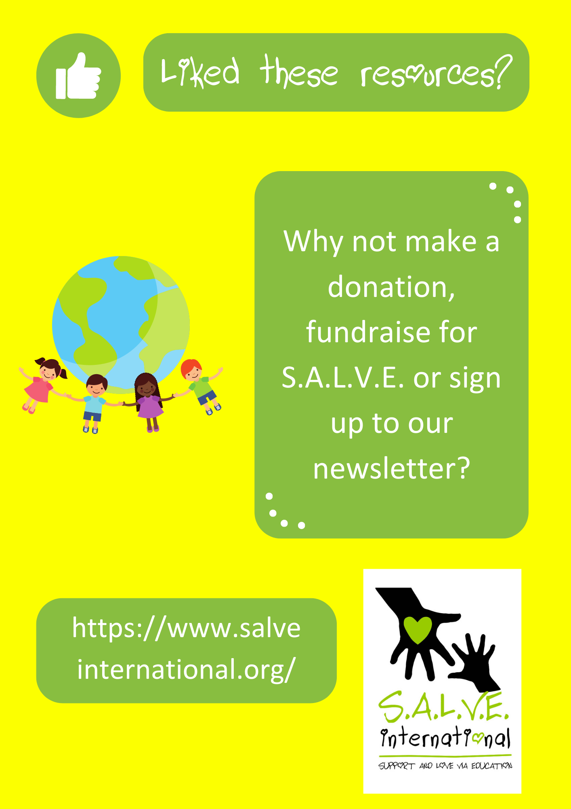

Photo Credits
Photo credits for PowerPoint presentation:
Slides 1 and 16 - (Clockwise from top left): 1. Jonathan McIntosh 2. Tanvirul Islam 3. Zirland 4. Peter Rimar 5. Biswarup Ganguly 6. Esther Dobson 7. Predrag Bubalo 8. Esther Dobson 9. Biswarup Ganguly 10. Sumanth Garakarajula
Slides 17-31 Thumb image from www.pixabay.com
Slide 34 – UN image from www.pixabay.com

Persuasive writing Techniques with Definitions

- Alliteration- Using a series of words with the same first letter
- Fact- Something true
- Rhetorical question- A question that is not designed to be answered but should make someone think
- Repetition- repeating a word or phrase two or more times to increase its impact
- Emotive Language – use of word and phrases that produce an emotional response
- Statistics- numerical data
- Anecdote- a short story about a real person or event
- Hyperbole- an exaggerated statement that’s not meant to be realistic but is used as a figure of speech
- Personal pronouns- he, she, it, they, him, her etc
- Power of three- using the same or similar image or idea three times
- Superlative- words ending in ‘st’ that shows the upper/lower limits of something e.g. highest, best, happiest
- Oxymoron- two contradictory words found in sequence or in a phrase ‘less is more’ ‘you’ve made a fine mess’.

Key Terms for Speech Writing
Alliteration |  | Two contradictory words found in sequence or in a phrase ‘less is more’ ‘you’ve made a fine mess’
Fact |  | Words ending in ‘st’ that shows the upper/lower limits of something e.g. highest, best, happiest
Rhetorical question |  | Using the same or similar image or idea three times
Repetition |  | Something true
Emotive Language |  | Numerical data
Statistics |  | A short story about a real person or event
Anecdote |  | Use of word and phrases that produce an emotional response
Hyperbole |  | Repeating a word or phrase two or more times to increase its impact
Personal pronouns |  | He, she, it, they, him, her etc
Power of three |  | Using a series of words with the same first letter
Superlative |  | A question that is not designed to be answered but should make someone think
Oxymoron |  | An exaggerated statement that’s not meant to be realistic but is used as a figure of speech
Draw a line from the key word on the left to the definition on the right. Use these definitions to help you to write your speech later in the lesson.

Name……………………….….
Homework: Street Connected children in Jinja
Use the following page of the S.A.L.V.E. International website to find the answers to answer the following:
https://www.salveinternational.org/salve-explained/history/
How many children currently live on the streets of Jinja?
……………………………………………………………………………………….………………....
How many children are currently out of school and earn a living on the streets?
……………………………………………………………………………………….………………....
Who, apart from these children, need support and why?
……………………………………………………………………………………….………………....
……………………………………………………………………………………….………………....
……………………………………………………………………………………….………………....
When was S.A.L.V.E International started?
……………………………………………………………………………………….………………....
What support did S.A.L.V.E aim to give homeless children?
……………………………………………………………………………………….………………....
……………………………………………………………………………………….………………....
……………………………………………………………………………………….………………....
Which type of children in particular would S.A.L.V.E like to target in the future and why?
……………………………………………………………………………………….………………....
……………………………………………………………………………………….………………....
Mike Asiya was one of the founders who started S.A.L.V.E, what job did he do in the organization?
……………………………………………………………………………………….………………....
Why was he particularly drawn to this work?
……………………………………………………………………………………….………………....
……………………………………………………………………………………….………………....
What three things did the three founders want children living on the streets to be able to access so they could have brighter futures?
……………………………………………………………………………………….………………....
……………………………………………………………………………………….………………....
……………………………………………………………………………………….………………....
Name……………………….….
ANSWER SHEET Homework: Street Connected children in Jinja
Use the following page of the S.A.L.V.E International website to find the answers to answer the following:
https://www.salveinternational.org/salve-explained/history/
How many children currently live on the streets of Jinja?
600
How many children are currently out of school and earn a living on the streets?
3000
Who, apart from these children, need support and why?
Families of the children, so they can sustain themselves when their child returns. This will hopefully stop the cycle of homelessness.
When was S.A.L.V.E International started?
2008
What support did S.A.L.V.E aim to give homeless children when it was founded?
Providing a halfway home, support to help children resettle with their families, education and hope for the future. We proud to now provide this and far more!
Which type of children in particular would S.A.L.V.E like to target in the future and why?
Girls. Because girls homelessness is often hidden as they are more vulnerable to abuse.
Mike Asiya was one of the founders who started S.A.L.V.E, what job did he do in the organization?
Counsellor
Why was he particularly drawn to this work?
He had experienced homelessness as a child
What three things did the three founders want children living on the streets to be able to access so they could have brighter futures?
Counselling, care and education

Your speech must cover the following:
- The difficulties faced by children on the streets in Uganda
- How S.A.L.V.E is working to reduce the number of children living on the streets
- Why this cause should be taken up by the UN
The speech should be 2 mins long
https://www.salveinternational.org
Topic/Theme

Introduction | Persuasive writing techniques to use:  - Alliteration  - Fact  - Rhetorical question  - Repetition  - Emotive Language  - Statistics  - Anecdote  - Hyperbole  - Personal pronouns  - Power of three  - Superlative  - Oxymoron
Argument 1

Argument 2

Argument 3

Ending/Conclusion | Look up the spelling of words using the dictionary

