Home Schooling Resources

The following activities are designed to be cross-curricula. They can be used in:
- Geography
- PSHE/Citizenship
- English
- P.E.
- Art

Our free teaching resources are designed to help teachers (or parents) explore important issues including children’s rights, global inequality and life on the streets with the next generation of learners. Informative and engaging, they aim to empower young people to engage critically with an important global issue while inspiring them to contribute to a fair and just world.

For more structured, in-depth lesson plans with accompanying PowerPoints, visit our website.

Let’s Learn About Uganda!

Uganda is a country in East Africa that is completely surrounded by other countries. It shares borders with Tanzania, Rwanda, Congo, Sudan, and Kenya. Uganda would fit inside the USA almost 41 times!
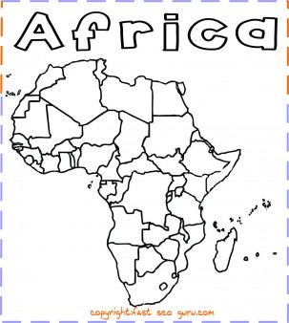

UGANDA

Have a go at colouring in this map of Africa using the colours in the Ugandan flag!

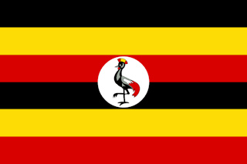
Did you know?
The three colours in the flag represent the African people, Africa’s sunshine and African brotherhood

Fun facts about Uganda:
- Lake Victoria is in Uganda and is the biggest lake in Africa! There are over 200 different types of fish that live there
- Kampala is the capital city, and is nicknamed the ‘Happy City’
- Ugandans love sport, and football is their national sport.

Who are S.A.L.V.E International?
- S.A.L.V.E. is a UK and Ugandan charity working hard to make sure there is “No street called home”
- ‘S.A.L.V.E.’ stands for “Support and Love Via Education”
- We support children on the streets to return home to their families (or another loving family) and to re-enter education.

There is a lot of inequality in Uganda (and all over the world), but charities like S.A.L.V.E. are determined to help!
So what can you do?
Let’s learn! By learning about Uganda, S.A.L.V.E and the lives of children in Uganda, you will be able to see how everyone across the world can help others, and by getting involved with S.A.L.V.E., you are helping more young people leave the streets for good.

Can you make a drawing here to show where you think children should sleep at night time?
No
Street
Called
Home

Why do children live on the street?

Below are some reasons why children might end up on the street. Draw a picture representing that reason.

Then create a large mind map style poster of why children end up on the stree
with your drawings attached.
My mum is mean to me
My family are too poor to look after me
My auntie tells me I need to get a job to get money for the family
I am an orphan, so I don’t have anywhere else to live
All my friends live on the streets and they say it’s fine
I can make money on the street
On the street I can do what I want
On the streets I can help my family survive by earning money
My family have abandoned me

Promoting Equality

You are a worker who is passionate about promoting equality. You have recently found out about the inequality in the UK and across the world and want to help. You decide to draft a law and write a speech to take to the government.

Circle the topic of inequality you are focusing on:
Homelessness Access to education

Domestic abuse Child rights

War Poverty Gender inequality

Why are you focusing on this topic?
Reason 1: ………………………………………………………………………………………………………………………………………………………………………………………………………………………………………………………………………………………………………………………………………………………………………………………………………………………………………………………………………………

Reason 2: ………………………………………………………………………………………………………………………………………………………………………………………………………………………………………………………………………………………………………………………………………………………………………………………………………………………………………………………………………………

What will the law you propose include?
Name of law: ……………………………………………………………………………………………………………………………
…………………………………………………………………………………………………………………………………………………
What will this law do: ………………………………………………………………………………………………………………
………………………………………………………………………………………………………………………………………………………………………………………………………………………………………………………………………………………………………………………………………………………………………………………………………………………………………………………
Will this law cost? If yes, how will you pay for it:………………………………………………………………………
……………………………………………………………………………………………………………………………………………………………………………………………………………………………………………………………………………………………………
Who will this law help:……………………………………………………………………………………………………………..
……………………………………………………………………………………………………………………………………………………………………………………………………………………………………………………………………………………………………
How will it be implemented:…………………………………………………………………………………………………….
……………………………………………………………………………………………………………………………………………………………………………………………………………………………………………………………………………………………………
…………………………………………………………………………………………………………………………………………………

Resilience and Art
Children living on the streets have a lot of resilience – this means they don’t give up when something is difficult.

What images do you think of when you think of resilience? For example, climbing a mountain, plants growing through rocks…
Have a go at drawing and colouring in something that represents resilience to you! Here are examples drawn by children that have been helped by S.A.L.V.E.
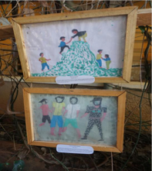
Draw your picture here:

\

Football Pairs

As we have already learnt, football is Uganda’s national sport. Try a game of football, or some passing/shooting skills in pairs.
Do this by tying a string (or a tie/belt – whatever you have) around two people’s arms and legs like this:
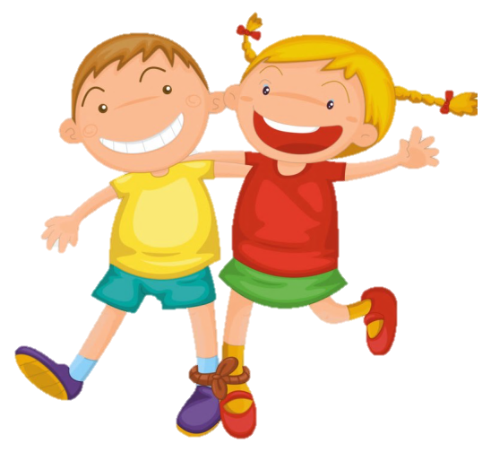

Then try to coordinate passing and shooting the ball – it’s trickier than you think!
Remember – patience and resilience are key! When it gets difficult you need to work together and overcome the problem together.

Jacob is 7 years old and lives in Jinja, a big city in Uganda. His favourite sport is football and he supports Manchester United. He loves to dance and play games, especially snakes and ladders. When he grows up he wants to be a bus driver. Unfortunately, Jacob ended up living on the street like many children in Uganda.
Before Jacob came to the street he was living with his mum after his dad sadly died. His mum was very poor and was unwell so she was unable to get a job. This meant that she couldn’t afford to send Jacob to school or feed him. She decided to take Jacob to live with his auntie. Jacob’s mum believed that his auntie would be able to take better care of him and she left him there. He had no way of contacting his mum again.
Unfortunately, Jacob’s auntie was also very sick. She already had six children of her own to look after and they lived in a small house, which was one room that was about the size of a normal bathroom in the UK. Jacob’s auntie was too sick to go to work so she sent Jacob to the street to collect scraps of metal and plastic bottles, which he could sell for around 20p a day.
He had to walk for miles to and from town every day. He didn’t get much food or any clean water to drink. When he came home from a day of searching through rubbish dumps, there was nowhere to have a wash. He had to give any money he made during the day to his aunt so that she could feed the whole family. His cousins were jealous of him and annoyed that his aunt had another child to feed so they used to hit him and bully him.
After a while, Jacob decided that it was better to stay in town at night and sleep on the street with the other children. This is very dangerous for any child but especially a child as young as Jacob.
Life on the streets was very hard. Every night he had to find a good place to sleep. People were often mean to him and sometimes would offer him dangerous drugs. He always went to sleep hungry and cold.
In Jinja there is a charity working with children on the streets called S.A.L.V.E. International. They help children who live on the streets by giving them a safe place to stay.
The staff at the S.A.L.V.E. centre where Jacob used to come during the day quickly realised that he had begun sleeping on the street. They took him home to meet his auntie and she explained the situation.
Jacob’s auntie requested that he should go to live somewhere else, like in the S.A.L.V.E. home, until she was better and could care for him and send him to school. Jacob stayed with S.A.L.V.E. until they could find his mum, who luckily was feeling a lot better. He is now living with his mum again and is doing well at school. Let’s hope that one day he can live his dream of becoming a bus driver.

Jacob’s Story: Questions
The story we read was about ............................................................................... .............................................................................................................................................................................................................................................................................................................................................................................................
Where was the story taking place?...............................................................
What is the same between Jacob and you? ......................................................... .............................................................................................................................................................................................................................................................................................................................................................................................
What are the differences between Jacob and you? ............................................. .............................................................................................................................................................................................................................................................................................................................................................................................
What were the big problems that Jacob faced when he was living on the street?................................................................................................................... ............................................................................................................................. ..............................................................................................................................................................................................................................................................
How does the story make you feel?...................................................................... ............................................................................................................................................................................................................................................................................................................................................................................................................................................................................................................................
Who did Jacob go to for help? What did they do? ...............................................
............................................................................................................................................................................................................................................................................................................................................................................................................................................................................................................................

Name:………………………………………………………………………
What have you learnt about Uganda?

Let’s see what you remember about Uganda, and why not do some research of your own to find out some interesting facts!
Well done – you’ve learnt a lot about Uganda now! Why not check out S.A.L.V.E. International’s website and look for more ways you can get involved

2) What is the name of Africa’s biggest lake? Hint: It has the same name as an old English Queen
3) Why are charities like S.A.L.V.E. International needed? Can you research 3 things they do to help inequality?

1)

2)

3)

4) Find 3 interesting facts about Uganda!

1)

2)

3)
- Circle the correct answer. Uganda is…

- Sandwiched between Kenya, Rwanda, South Sudan and more
- On the East coast, just above South Africa
- In the North West of Africa, near Burkina Faso

