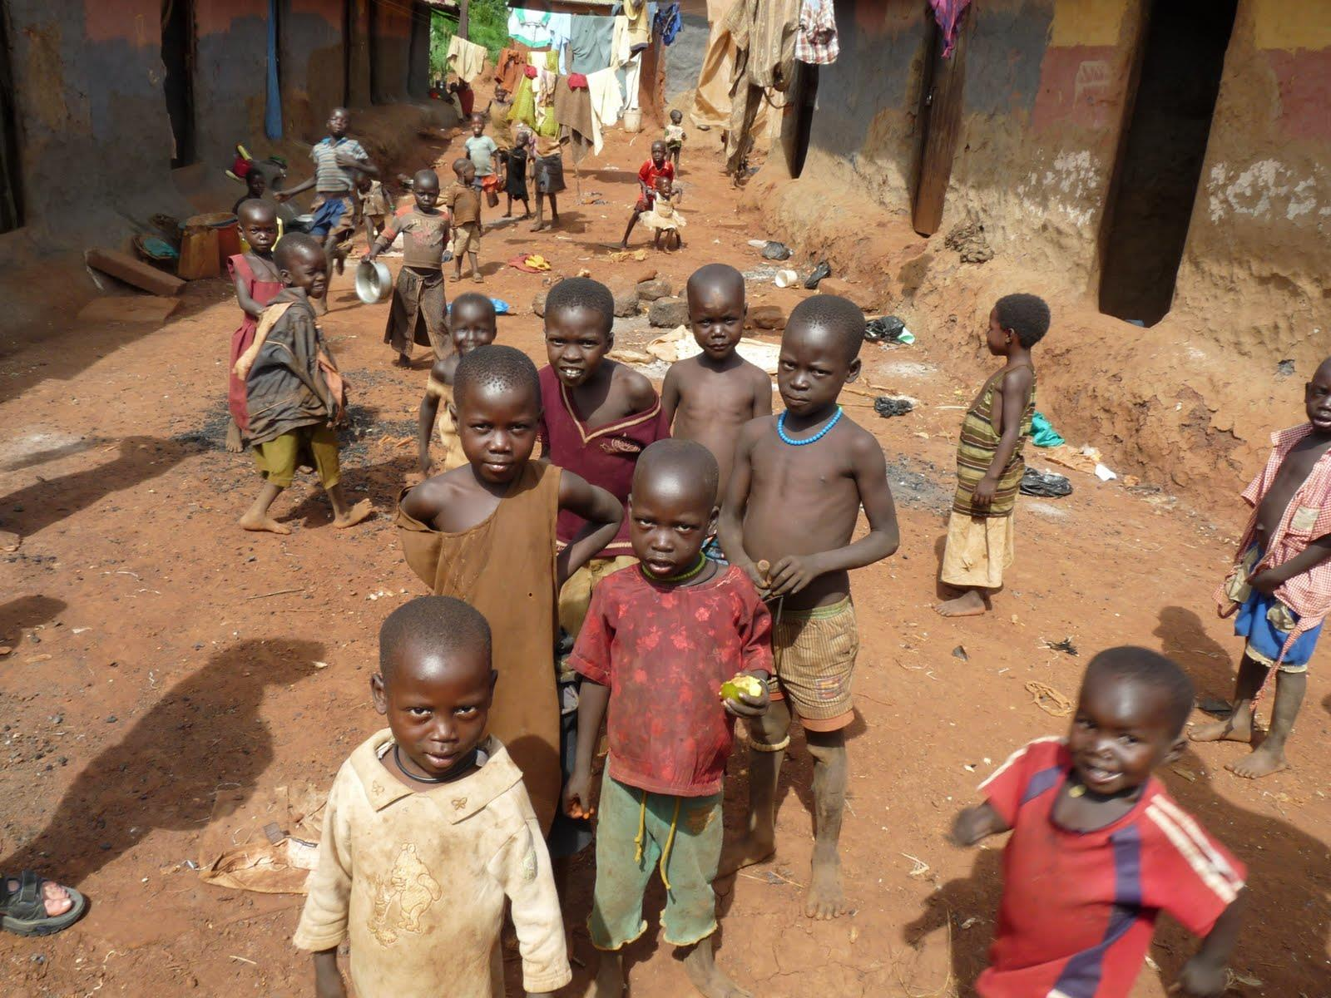

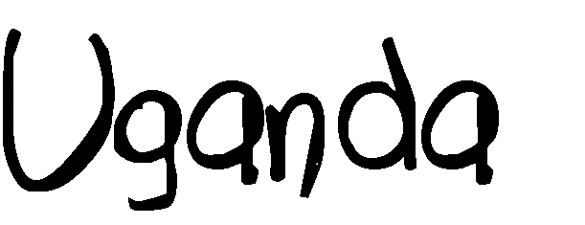

This Session
The lessons engage with learning objectives from subjects including Citizenship, PSHE, English, Geography and Art and Design. These lessons are also in line with the United Nations Sustainable Development Goals.
English
Speaking and listening: Group discussion to stimulate interaction (learning to speak confidently and listen to what others have to say) and give pupils the chance to organise and express thoughts and feelings.
Geography
Knowledge and understanding: This lesson helps build pupils’ geographical enquiry and skills in a range of ways. It helps develop an increased sense of the wider world and similarities and differences between countries as well as starting to let children engage with human and social features of other countries. It encourages them to ask geographical questions about people, places and environments and use geographical skills and resources, such as maps and photographs.
Skills: This lessons helps children develop and use geographical vocabulary, teaches them to use and make maps at a range of scales and identify and describe where places are through the use of secondary sources of information.
Global Citizenship & PSHE
Knowledge and Understanding: Lesson as a whole raises awareness of rich and poor, similarities and differences between people, and a sense of the wider world.
Skills: Encourages the development of an enquiring mind, gives opportunity to begin to state opinion, facilitates empathising and responding to others and making links between our lives and the lives of others.
Values and Attitudes: Develops interest in and concern for others, stimulates engagement with social justice and what is right and wrong.
Art and Design
Knowledge and understanding: Activity 4 allows space for pupils to begin to understand colour, shape, space, pattern and texture and to use them to represent their ideas and feelings.
Skills: Activity 4 also gives pupils the chance to develop their creativity and imagination.
Activity | Resources | Suggested Time spent
Activity 1:  Start by using the PowerPoint (Lesson PowerPoint) to recap what was learnt in Lesson 1, including: Child Rights + Children on the streets around the world.  Ask students if there was anything they found surprising about the previous lesson | Lesson PowerPoint | 5 minutes
Activity 2:  Hand out the map sheets (below). The maps are also included in the PowerPoint.  Map 1 (world map): Use map 1 to get the children to locate England, Europe and Africa. Ask pupils where they have been on holiday and help them locate those places. Do any of the pupils families come from other countries? If so, where? You can take this opportunity to remind children about the difference between countries and continents.  Map 2 (Africa map): Use this map to locate Uganda in Africa.  Discuss: Uganda has a lot of countries around it, which countries are Uganda’s closest neighbours? Who are the closest neighbours to England?  Map 3 (Uganda map): Use map 3 to get pupils to locate Kampala, the capital city of Uganda. Then locate Jinja, a city in Uganda that we will be focussing on. You can talk about the different colours on the map and what they represent (Blue: lakes and rivers. Green: National Parks. Pink: Neighbouring countries) and any other geographical discussions (e.g. how would you describe the location of Jinja? What is a capital city? Name some other rivers, lakes and capital cities. Compare a landlocked country like Uganda and an island nation like the UK.) | Maps below, 1 set per pupil | 15 minutes
Activity 3:  Use the PowerPoint to introduce pupils to Uganda and Jinja. Feel free to edit the information with the slides to include as much or as little information as you feel is suitable for your class. | Lesson PowerPoint | 10 minutes
Activity 4:  Split the class into small groups or pairs. Ask pupils to draw a map of their local area, including places that are important to their lives. Each member of the group should draw at least one place e.g. library, home, school.  Then ask pupils to imagine they are living on the streets, marking the below on their maps.  - Where you go to sleep  - Where you go to wash  - Where you go to get food  - Where you go to have fun  For each one, ask pupils to consider ‘Why did you pick that place?’  Once complete, ask each group to display their map and feedback to the rest of the class. | Plain paper, colouring pens/pencils | 25 minutes
Activity 5/Plenary:  Ask pupils to reflect on today’s lesson and have each table/group come up with 1 thing they will take away/something they have learnt | N/A | 5 mins

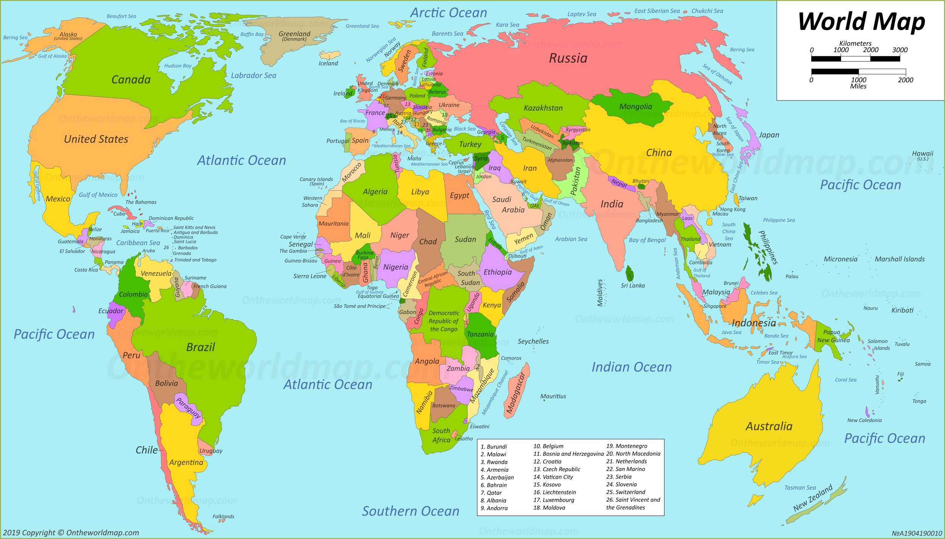
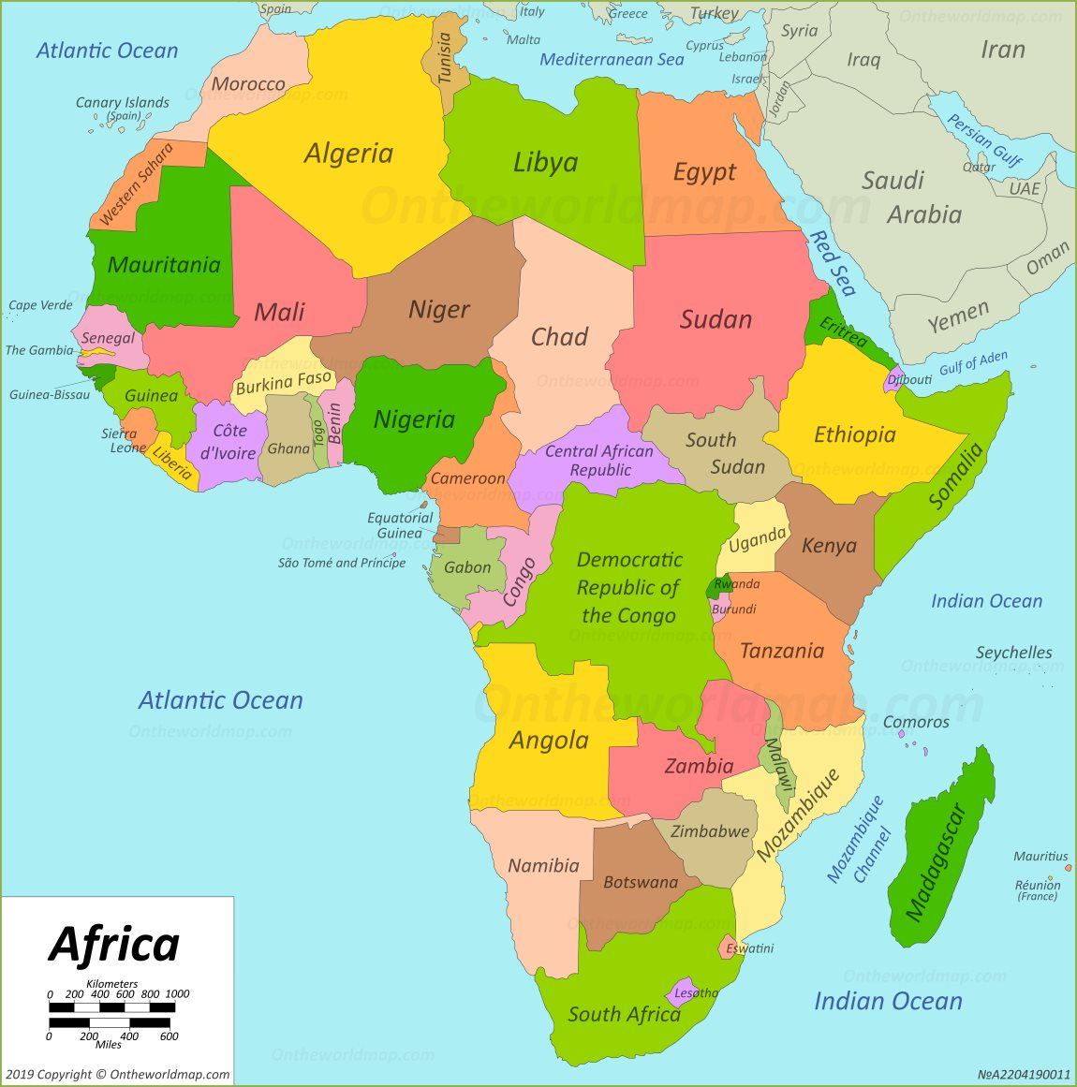
Map of Africa
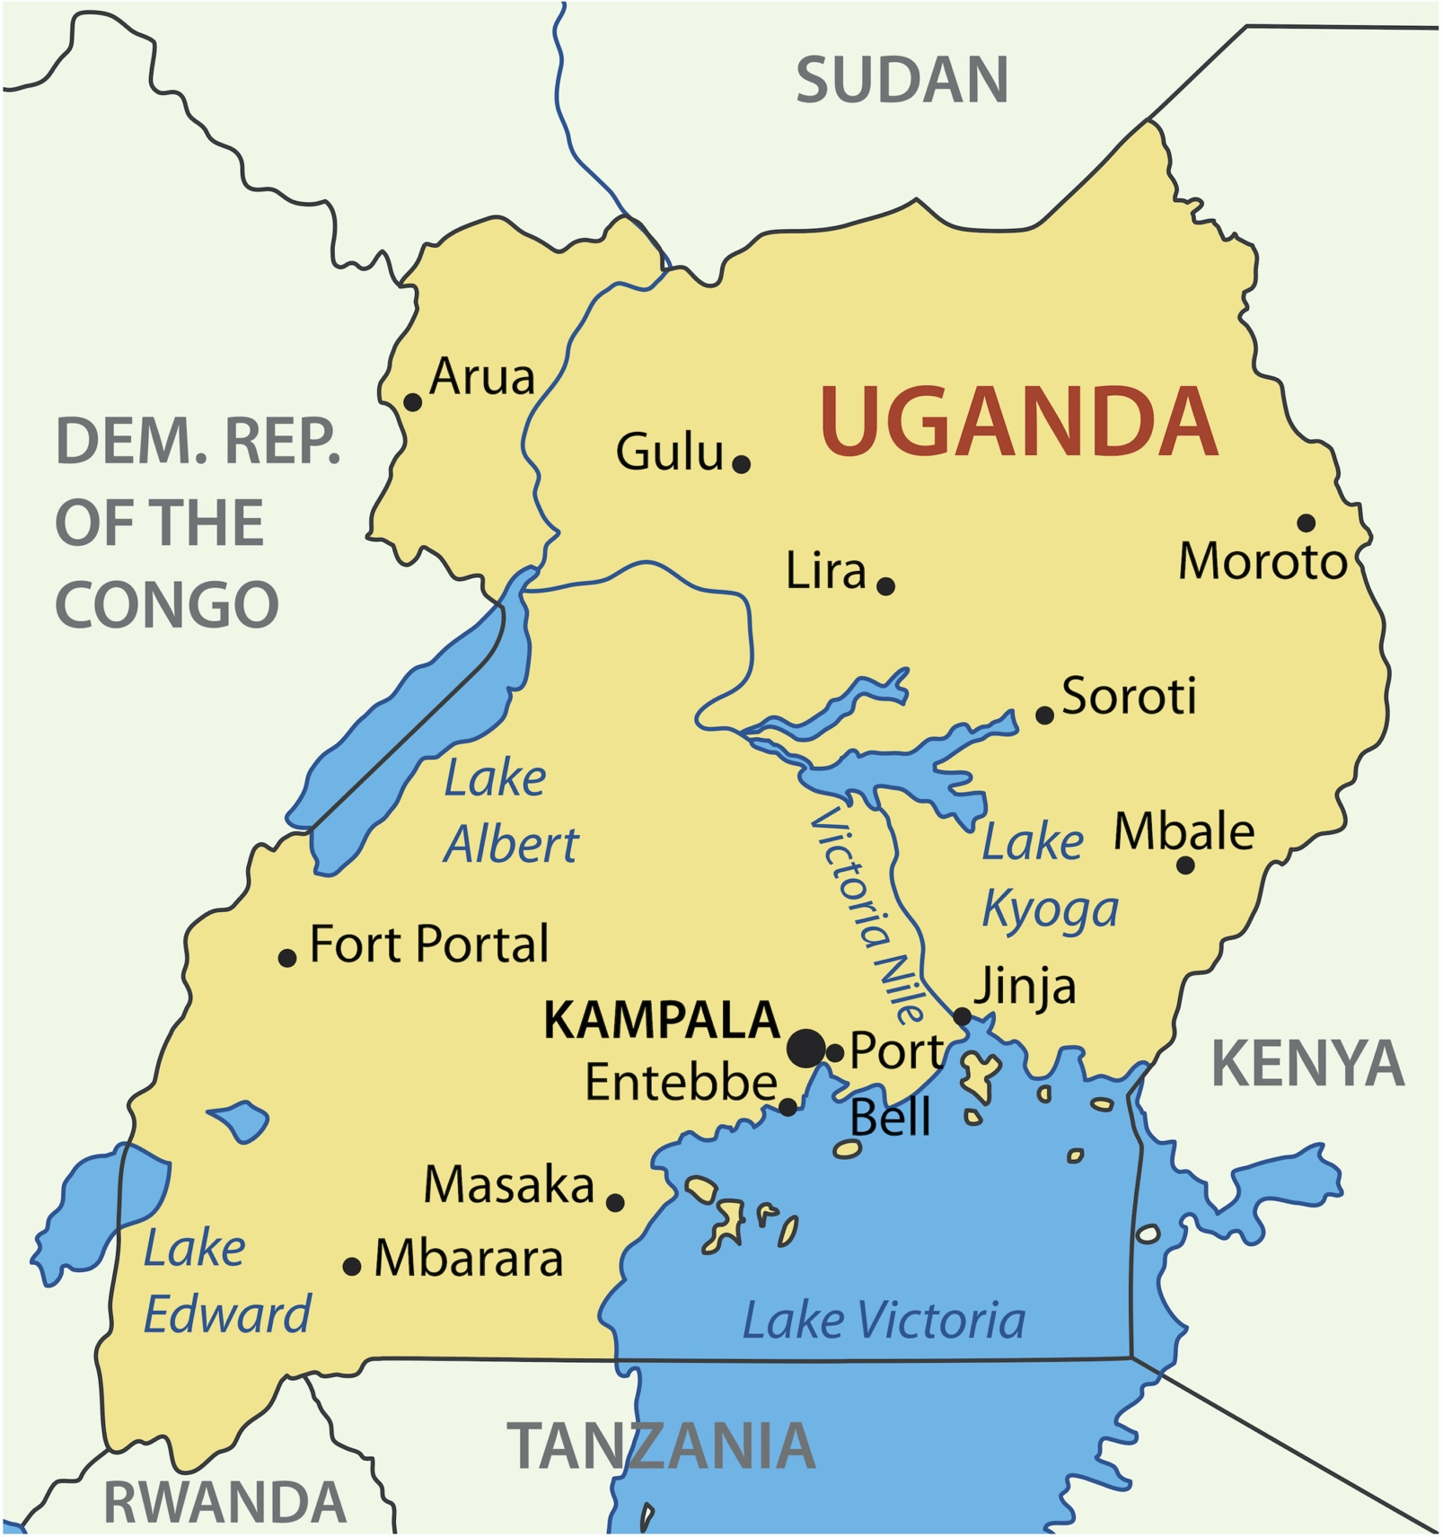

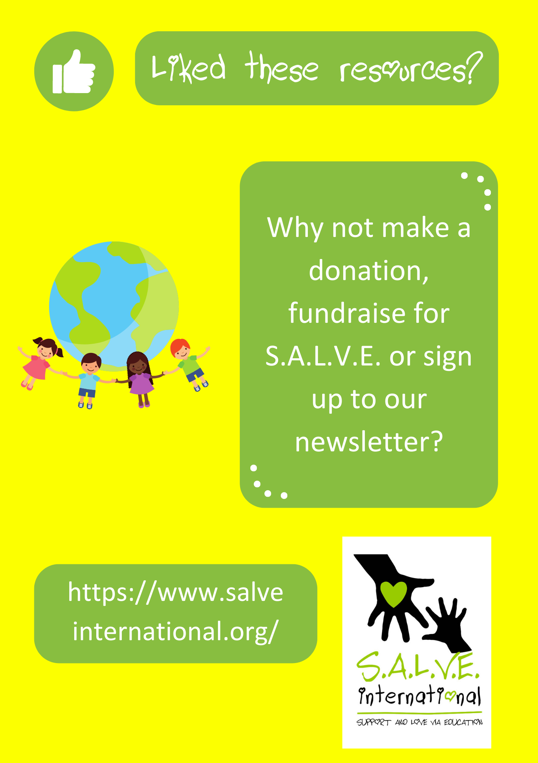

Accreditation:
Photo credits for PowerPoint presentation:
Slide 1, 2, 6, 10: (Clockwise from top left): 1. Jonathan McIntosh 2. Tanvirul Islam 3. Zirland 4. Peter Rimar 5. Biswarup Ganguly 6. Esther Dobson 7. Predrag Bubalo 8. Esther Dobson 9. Biswarup Ganguly 10. Sumanth Garakarajula
Slide 4: Nicola Sansom, Salve International
Slide 12, 13, 14, 17: Photos by Esther Dobson, Salve International
Sources of information:
Slide 11: Population 46 million: https://www.worldometers.info/world-population/uganda-population/
Slide 13: Family size average of 5 children: https://www.africageoportal.com/datasets/7d67a1f9ed68499dbec68b94dc8af8e5
Slide 15: Number of people in poverty in Uganda: https://www.worldbank.org/en/country/uganda/brief/uganda-poverty-assessment-2016-fact-sheet
Maps:
https://www.ephotopix.com/political-maps/uganda-map/
WorldMap
WorldAtlas

